

**Getting Started**

**Order Tracking**

Prepared by: Andromeda Trading Ltd

Date:

Version:

INDEX

INDEX 2

1 Revision Control 3

1.1 Document Approval 3

2 Introduction 4

2.1 Purpose 4

2.2 Scope 4

2.3 Definitions and Abbreviations 4

2.4 References 4

2.5 Overview 4

2.6 Contact Details 4

3 Launching the application 4

3.1 Step One 4

3.2 Step Two 4

3.3 Step Three 4

4 logging into the system 4

4.1 Logging In 4

5 system layout 4

5.1 System Areas 4

6 (MOdule A) 4

7 (MODULE B) 4

8 (MoDULE C) 4

9 (MODULE D) 4

10 (MODULE E) 4

11 (MODULE F) 4

12 (MODULE G) 4

13 (MODULE H) 4

# Revision Control

| **Revision** | **Description of Changes** | **Revised By** | **Signed Off** | **Date** |
| --- | --- | --- | --- | --- |
| 1.0 |  |  | No |  |
|  |  |  |  |  |
|  |  |  |  |  |

## Document Approval

|  |  |  |  |
| --- | --- | --- | --- |
| **Signatory** | **Designation** | **Signature** | **Date** |
| Ben Cole | CIO |  |  |
| Ben Portsmouth | CEO |  |  |

# Introduction

## Purpose

The purpose of this documentation is to guide users through Order Tracking and to be used for training purposes for clients

The following details that will be included in this document:

* Process flows for the system
* Explanation of processes
* Screen Explanations
  + Detailing each field
  + Detailing buttons/commands that can be run from screen
  + Definitions of Data Headings

## Scope

This document will cover the available Order Tracking functionality in version X.X.

## Definitions and Abbreviations

|  |  |
| --- | --- |
| **Abbreviation** | **Description** |
| Order Tracking |  |
| Rameses | Andromeda’s POS system |
|  |  |

|  |  |
| --- | --- |
| **Concept** | **Definition** |
|  |  |
|  |  |
|  |  |
|  |  |
|  |  |
|  |  |
|  |  |

## References

|  |  |  |
| --- | --- | --- |
| **Document Name** | **Version** | **Date** |
|  |  |  |
|  |  |  |

## Overview

This document is designed to be used for user reference and training

## Contact Details

For further information please contact Andromeda Trading Ltd on

+44 (0)870 118 8010

or visit

<http://www.androtech.com>

## Step 1: Unpack

Unpack each device. There should be a GPS tracking device, charger and clip on holster.

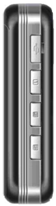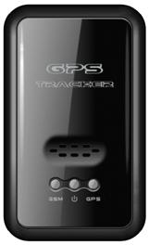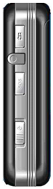

Power button

Red light - GSM (mobile phone) indicator

Charger socket

Blue light - GPS indicator

Yellow light - power indicator

## Step 2: Charge

If any of the lights are on (or flashing) then you should switch the device off before charging it. Slide the power button on the side of the device to turn it off. All lights should go off to indicate the device is powered off. The device may not charge fully if left switched on while charging.

Plug the battery charger into both the mains power socket and the GPS tracking device. The power socket is located on the side of the GPS tracking device. A red light on the battery charger indicates that the attached tracking device is charging. The yellow power light on the tracking device should also flash to indicate that it is charging. The red light on the battery charger will go out when the device is fully charged.

For the first charge you should leave to device plugged in to the battery charger for at least 12 hours. After the initial 12 hour charge the battery can be fully charged in 3 to 4 hours.

## Step 3: Check Rameses

Once drivers have been clocked in, select a driver from the list and press the  button. A list of tracker names should appear on the next dialog. The device name is physically printed on the back of each device. Check that all the GPS tracking devices are shown in the list in Rameses.

## Step 4: Assign trackers

To assign a tracker in Rameses select an available one from the list and then press the 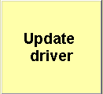 button. A + symbol before a driver’s name identifies that they have a tracker assigned to them.

## Step 5: Switch on

On the side of the GPS tracking device, slide the power button to switch it on. The lights will flash to indicate that the device is powered on and a start-up sequence will begin.

The tracking device will attempt to connect to the mobile phone network. It will also attempt to get a “first fix” using the GPS satellite network which can take a few minutes. To speed this up, give the unit a clear view of the sky. Take it outside for a couple of minutes.

## Step 6: Check the map

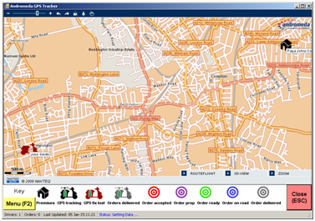

The driver should appear on the map

## Step 7: Making a delivery

The device works best when it can see the sky. Ideally it should be clipped to clothing using the holder provided. Watch the map as the driver makes the delivery. Every few seconds, the driver icon should move to indicate the driver’s current position. The driver icon should move to the order and then back to the store.

## Step 8: Finishing up

When the driver is clocked off in Rameses it is important that the GPS tracking device is put on charge. Otherwise it may run out of battery the next day. Slide the power button on the tracking device. Once released, all lights on the tracking device should go off. Plug the device into the battery charger and leave to charge for at least 4 hours or overnight.